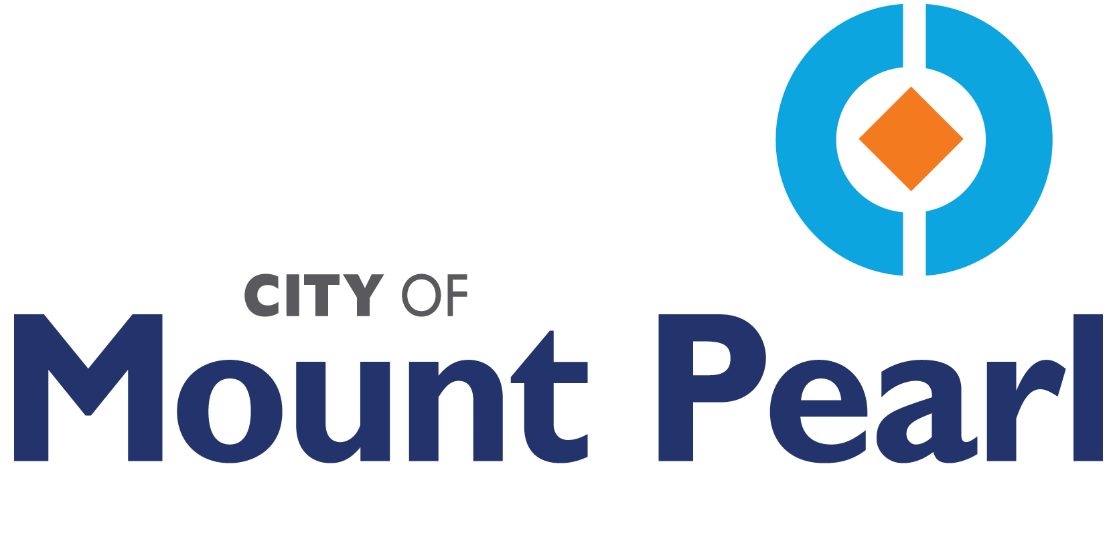

PLANNING ENGINEERING AND DEVELOPMENT
PUBLIC INFORMATION REPORT

DA24-0081 – 50-56 MACCARTHY CRESCENT – NEXTGEN CONSTRUCTION INC.
PROPOSED RESIDENTIAL INTENSIFICATION PROJECT

THE PROPOSAL

The city is in receipt of an application by NextGen Construction Inc. to develop two (2) six-unit apartment buildings at 50-56 MacCarthy Crescent. The subject property is located in the Residential - Medium Density (RMD) Use Zone and a Residential Intensification Project may be considered for approval by Council after adequate public notification has been undertaken in accordance with Regulation 4.17, of the Mount Pearl Development Regulations 2010.

A location map and proposed site plan are attached for reference.

RELATIONSHIP TO SURROUNDING LAND USES

The subject property is located at 50-56 MacCarthy Crescent. Two (2) duplexes currently exist on the site. The current zone is Residential – Medium Density (RMD) with Residential - High Density (RHD) at the rear of subject properties on Michener Avenue.

RELATIONSHIP TO ADOPTED PLANS AND REGULATIONS

Mount Pearl Municipal Plan 2010

The proposed development is located within the Residential Land Use Designation. The proposal is subject to meeting the goals, objectives and policies of the City of Mount Pearl Municipal Plan 2010.

Mount Pearl Development Regulations 2010

The subject property is located within the Residential – Medium Density Use Zone. The proposed development does not meet the development regulation requirements for the Use Zone. However, Council may, at its discretion, approve a residential intensification project which is designed to improve the affordability of housing or to make more effective and efficient use of land and municipal services, and which does not meet the requirements of the Use Zone Schedules in Section 11 provided that:

The development is suitable to the physical conditions, municipal servicing, and road capacity of the area and is compatible with the existing neighbourhood character; in considering an application for a residential intensification project, Council shall, without limiting the generality of the foregoing, consider:

(a) the location of the land;
(b) the demand on schools, services, and utilities;
(c) the form and character of adjacent developments;
(d) the implications for the transportation system;
(e) the proposed housing form and urban design and relationships to adjacent uses;
(f) the height and density in relation to surrounding uses; and
(g) the impact of the development on view sheds and shadowing of adjacent properties;

Council may consider deviations from established zoning standards as outlined in the Regulations if Council deems the residential intensification project appropriate and suitable to the neighbourhood and area; and the residential intensification project is processed in accordance with Regulation 4.17.

Public feedback process

The public is advised that Council invites feedback on the proposed residential intensification in writing no later than 12:00 noon, Friday, July 19, 2024. Comments received form part of the public record. If you do not wish your name attributed to your submission, please advise the city. A public briefing session has been scheduled for Thursday July 25, 2024, 7:00 PM at City Hall, located at 3 Centennial Street. All written submissions will be considered by Council prior to making its decision on the matter.

If you have any questions or wish to attend the scheduled briefing session, please contact Jonathan Delaney at jdelaney@mountpearl.ca or Catherine Power, Manager of Development and Planning at cpower@mountpearl.ca or by phone at (709) 748-1000.

Attachments:
- Location Map
- Site Plan

